|  |  |
| --- | --- |
| Day | Topics |
| 1 | Introduction HTML5 Create your own website by using tags like head, title, body, table, br, hr, form, and frameset.  CSS Style like padding, margin, width, height and bgcolor.  JAVASCRIPT properties, methods and events.  ReactJS - introduction , React Js Installation, Architecture,  Creating React Application, React-JSX, React Component, |
| 2 | React styling, React properties, React Event Management, React List, React Hooks, React State Management ,React Form ,React Conditional Rendering programming,  React Animations. |
| 3 | MongoDB – nosql Database to create, insert, drop, update and Delete rows, Inserting Multiple Documents, Using Limit and Skip methods |

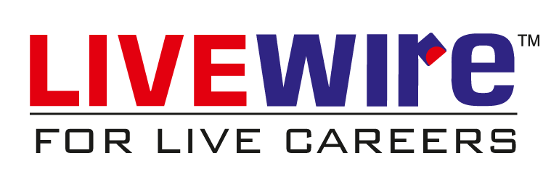

Full Stack Development